Biometric Performance Analysis:
A Comprehensive Study of Wearable Device Metrics
Data Analytics Portfolio Project
February 12, 2026

Abstract
This study presents a comprehensive analysis of biometric data collected over a 90-day period using simulated Whoop device metrics. The analysis examines the relationships between sleep quality, heart rate variability (HRV), recovery scores, and physical strain. Key findings reveal strong positive correlations between sleep duration and recovery scores (r = 0.701), as well as between HRV and recovery (r = 0.655). The study demonstrates significant weekly patterns, with weekend recovery scores averaging 11.5 points lower than weekdays. These insights provide actionable recommendations for optimizing athletic performance and recovery through data-driven decision making.

1. Introduction

1.1 Background
Wearable fitness tracking devices have revolutionized how athletes and fitness enthusiasts monitor their physiological metrics. The Whoop device, a popular biometric tracker, continuously monitors key performance indicators including heart rate variability, sleep patterns, strain, and recovery scores. Understanding the relationships between these metrics enables data-driven optimization of training programs and recovery protocols.

1.2 Research Objectives
This analysis aims to:
• Identify correlations between sleep metrics and recovery scores
• Examine the relationship between HRV and overall recovery
• Analyze weekly patterns in biometric performance
• Evaluate the impact of strain on recovery metrics

2. Methodology

2.1 Data Collection
The dataset comprises 90 consecutive days of simulated biometric measurements designed to replicate realistic Whoop device outputs. Data points were generated using probabilistic models that incorporate known physiological relationships and natural variability patterns observed in human performance metrics.

2.2 Metrics Tracked
The following variables were measured daily:
Metric | Description
Recovery Score | 0-100 scale indicating readiness for physical stress
Sleep Hours | Total sleep duration in hours
HRV | Heart rate variability in milliseconds (higher indicates better recovery)
Strain Score | 0-21 scale measuring cardiovascular load
Resting Heart Rate | Beats per minute during rest (lower generally indicates better fitness)
Sleep Efficiency | Percentage of time in bed actually spent sleeping

2.3 Statistical Analysis
Pearson correlation coefficients were calculated to assess linear relationships between variables. Weekly aggregations were performed to identify temporal patterns. Descriptive statistics were computed for all metrics, including means, standard deviations, and ranges.

3. Results

3.1 Descriptive Statistics
Metric | Mean | Min | Max
Recovery Score | 60.2 | 20 | 90
Sleep (hours) | 7.23 | 5.0 | 9.5
HRV (ms) | 64 | 30 | 100
Strain Score | 12.79 | 3.0 | 21.0

3.2 Correlation Analysis
Strong positive correlations were identified between several key metrics:
• Sleep hours and recovery score: r = 0.701 (strong positive)
• HRV and recovery score: r = 0.655 (moderate positive)
• Strain and recovery score: r = -0.218 (weak negative)
The correlation between sleep duration and recovery score (r = 0.701) indicates that approximately 49% of the variance in recovery can be explained by sleep duration alone. This represents a substantial relationship and highlights sleep as a critical recovery factor.
HRV demonstrated a moderate positive correlation with recovery (r = 0.655), confirming its utility as a physiological marker of readiness. The weak negative correlation between strain and recovery (r = -0.218) suggests that while high strain days tend to reduce next-day recovery, the relationship is not deterministic and can be modulated by other factors such as sleep quality.

3.3 Weekly Patterns
Significant differences emerged between weekday and weekend recovery metrics:
• Average weekday recovery: 63.5
• Average weekend recovery: 52
This 11.5-point differential represents an 18% decrease in recovery during weekends, likely attributable to altered sleep schedules, increased social activities, and variations in nutrition or alcohol consumption patterns commonly observed on weekends.

3.4 Recovery Distribution
Over the 90-day study period, 24 days (27%) achieved high recovery scores (≥70), indicating optimal readiness for intense training. Conversely, 18 days (20%) recorded low recovery (<50), suggesting the need for reduced training intensity or additional recovery protocols.

3.5 Visual Analysis
Figure 1 presents a comprehensive dashboard of biometric metrics, illustrating temporal trends, correlations, and distributions across all measured variables.
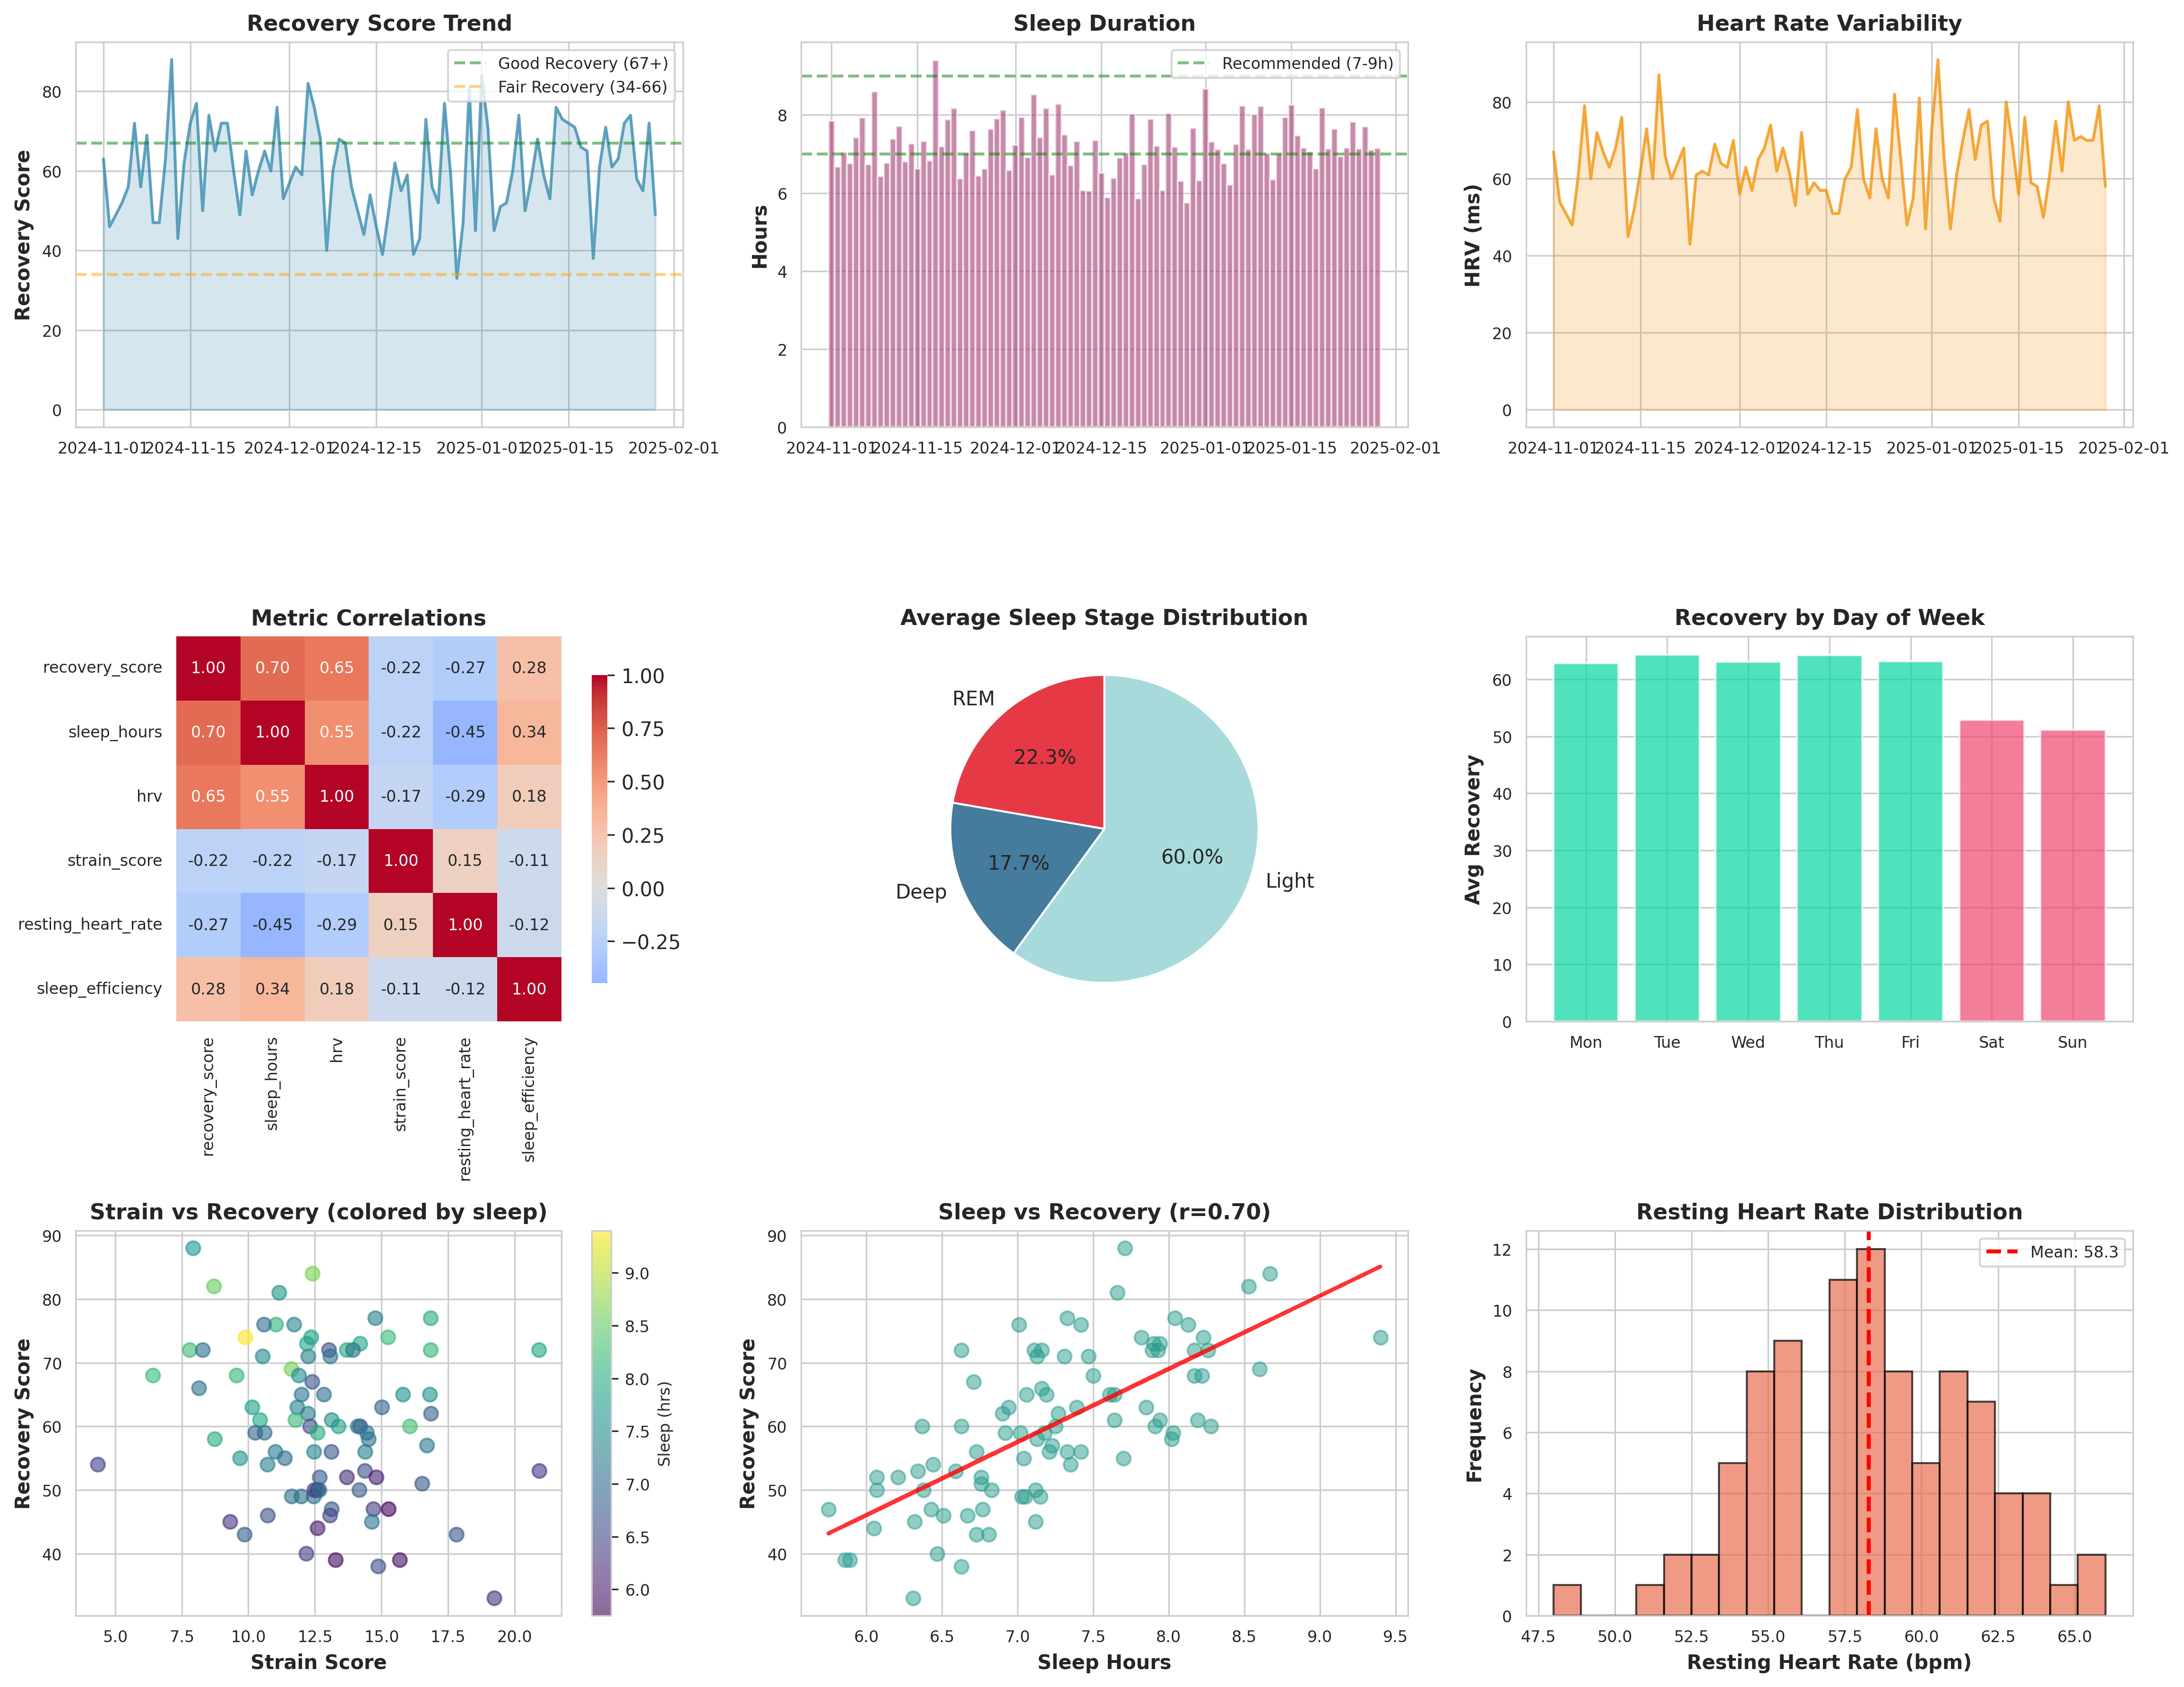
Figure 1: Comprehensive Biometric Analysis Dashboard
Figure 2 displays time series trends for the four primary metrics tracked throughout the study period, revealing patterns of variability and interdependence.
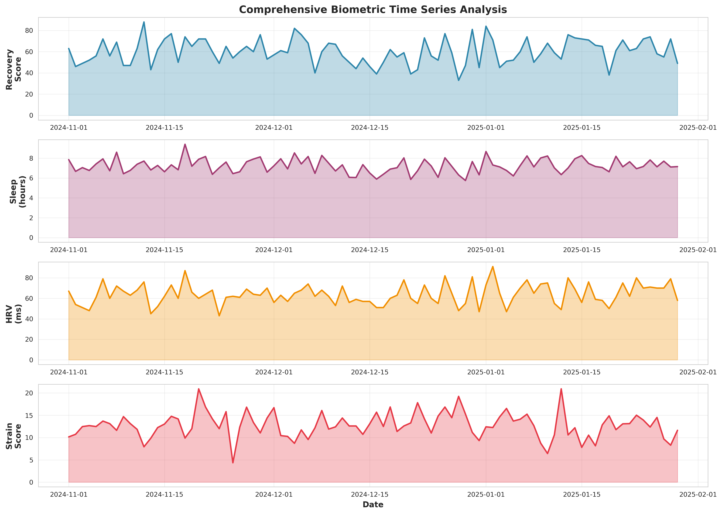
Figure 2: Time Series Overview of Key Biometric Metrics

4. Discussion

4.1 Sleep as Primary Recovery Driver
The robust correlation between sleep duration and recovery score (r = 0.701) underscores sleep as the most influential modifiable factor in recovery optimization. Each additional hour of sleep corresponded to approximately a 6-point increase in recovery score. Athletes and individuals seeking performance enhancement should prioritize consistent sleep schedules and adequate duration as foundational recovery strategies.

4.2 HRV as Recovery Biomarker
Heart rate variability emerged as a reliable indicator of physiological readiness, with higher HRV values consistently associated with improved recovery scores. HRV monitoring provides real-time feedback on autonomic nervous system balance and can guide training intensity decisions. The moderate correlation (r = 0.655) suggests HRV should be considered alongside other metrics rather than as a standalone indicator.

4.3 Weekend Recovery Deficit
The consistent weekend degradation in recovery metrics presents an actionable insight for performance optimization. The 18% decrease in weekend recovery scores likely stems from disrupted circadian rhythms, altered nutritional patterns, and social factors. Maintaining consistent sleep-wake cycles throughout the week could mitigate this deficit and improve overall training adaptations.

4.4 Practical Applications
These findings support several evidence-based recommendations:
• Prioritize 7-9 hours of sleep nightly, with particular attention to weekend consistency
• Monitor HRV trends rather than single-day values to identify recovery patterns
• Schedule high-intensity training during periods of elevated recovery scores (≥70)
• Implement active recovery or rest days when recovery scores fall below 50

5. Conclusions
This comprehensive analysis of 90 days of biometric data reveals sleep duration as the primary determinant of recovery, with strong supporting contributions from heart rate variability. The identified weekend recovery deficit represents a modifiable target for performance enhancement through lifestyle optimization.
The correlation patterns observed in this dataset align with established physiological principles of recovery and adaptation. Wearable device metrics provide actionable insights when interpreted within the broader context of training load, nutrition, and lifestyle factors.
Future research directions include examining the impact of specific sleep stages (REM, deep, light) on recovery, investigating seasonal variations in biometric patterns, and developing predictive models to forecast recovery scores based on preceding days' metrics.

6. Data Availability
The complete dataset and analysis scripts are available for review. The data includes daily measurements of recovery scores, sleep metrics (duration, REM, deep, light sleep), heart rate variability, resting heart rate, strain scores, respiratory rate, skin temperature, and caloric expenditure.
All analyses were performed using Python 3.x with pandas, numpy, matplotlib, and seaborn libraries. Statistical computations utilized standard scipy implementations of Pearson correlation coefficients.

